**USER MANUAL** – DCS Academic Monitoring System

1. Users will always be first directed to the welcome page of the system which contains a text box, a dropdown menu, and two buttons, Search and Show All, for input.

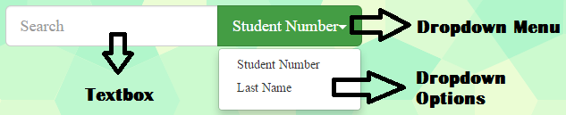

C:\Users\Olivia Demetria\Desktop\Pictures\search.png

C:\Users\Olivia Demetria\Desktop\Pictures\show all.png

* 1. Click the text box to enter your search query. Any character will be accepted, but they may not be valid.
     1. If users want to search for a student number, enter a number that is 9 or less, characters long. Then make sure that the current option displayed in the dropdown menu is “Student Number.” If it is not the current selection, click the dropdown menu, and then click Student Number in the displayed options. After that, click the Search button to display the table containing all the important information of students with the student number specified.
     2. If users want to search for a last name, type in any string inside the text box, and then make sure again that the current option displayed in the dropdown menu is “Last Name.” If it is not the current selection, click the dropdown menu, and then click Last Name in the displayed options. After that, click the Search button to display the table containing all the important information of students with the last name specified.
  2. Click the Show All button to display the table containing all the important information of all students in the system’s database.

1. After clicking the buttons Search or Show All on the welcome page, users will be directed to the home page similar to the one below:

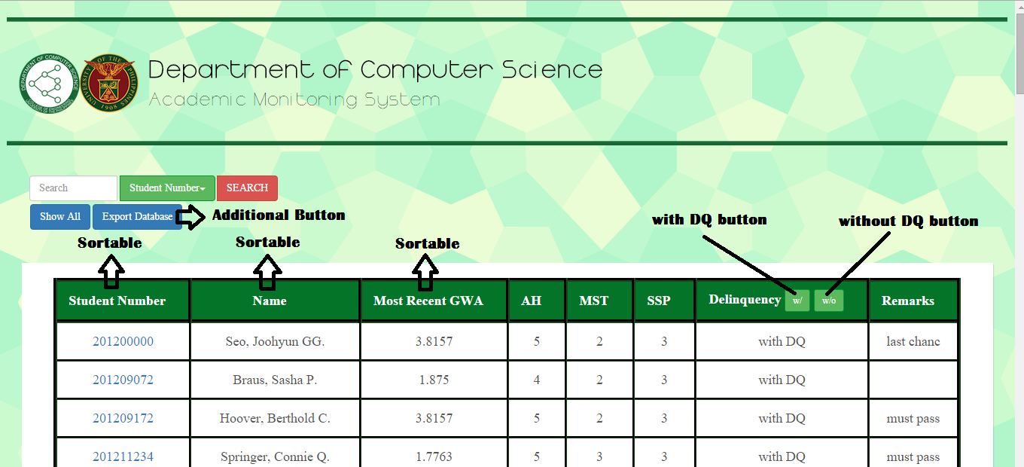

* 1. User input is the same as in 1.1.1 and 1.1.2.
  2. Clicking the export database button creates a db.csv file in the AMS folder. The db.csv file contains the student number, subjects and grades of each student in the system’s database.
  3. Table
     1. There will be a table displayed if there are matches in the database with the user inputs. If there are none, the system will display “No results found.”
     2. The table has 8 columns: Student number, name, most recent GWA, AH, MST, SSP, Delinquency, and Remarks
     3. The columns Student Number, Name, Most Recent GWA are all clickable and sortable in either ascending or descending order
     4. The column Delinquency has two buttons: the w/ (with) button and the w/o (without) button. Clicking the with button will only display the table entries of students only without delinquencies